**INDIVIDUAL APPLICATION FOR**

**WALLER COUNTY BAIL BOND LICENSE**

(You must submit one Original and 3 copies to the Bail Bond Administrator)

ORIGINAL { } RENEWAL { } LICENSE NUMBER

(If Original, leave blank)



1. Name of Applicant

2. Date of Birth

3. Home Address

4. Home Telephone ( )

5. Name of Spouse (if applicable) _

6. Name under which business will be conducted ________________________________ if business is an assumed name, attach a file-marked copy of the Assumed Name certificate as ***Exhibit "A"****.*

7. Business Address

8. Business Telephone ( )

9. I am a citizen of the United States of America { } Yes { } No

10. I am a legal resident of the State of Texas { } Yes { } No

11. I am at least 18 years of age { } Yes { } No

12. I have attached as ***Exhibit "B"*** a photograph of myself { } Yes { } No

13. I have attached hereto as ***Exhibit "C"*** my fingerprints { } Yes { } No

14. I possess financial resources required to comply with Chapter 1704.160 of the Texas

Occupations Code. { } Yes { } No

15. Attached hereto as ***Exhibit "D"*** is documentary evidence that in the two years preceding the date this application was filed, I have been continuously employed by a person licensed under this chapter for at least one year and not less than thirty (30) hours per week, excluding annual leave, and have performed duties that encompass all phases of the bonding business. { } Yes { } No

16. Attached hereto as ***Exhibit "E"*** is documentary evidence that in the two years preceding the date this application was filed, I have completed at least eight hours of continuing legal education in criminal law courses or bail bond law courses that are approved by the State of Texas and that are offered by an accredited institution of higher education in the State of Texas. { } Yes { } No

17. Since August 27, 1973, have you been finally convicted of a misdemeanor involving moral turpitude or a felony? { } Yes { } No

18. I authorize, allow, and permit the Waller County Bail Bond Board to review my

criminal history and confirm that since, August 27, 1973, I have not been finally convicted of a misdemeanor involving moral turpitude or a felony. { } Yes { } No

19. Attached hereto as ***Exhibit "F"*** is a complete sworn financial statement including an

Authorization of Release. { } Yes { } No



20. Attached hereto as ***Exhibit "G"*** are three (3) letters of recommendation, each from a person who is reputable and has known me for at least three (3) years and state that I have a reputation for honestly, truthfulness, fair dealing and competency - and recommends that the Waller County Bail Bond Board issue the license.

{ } Yes { } No

21. I intend to deposit with the Waller County Treasurer cash or the cash value of a certificate(s) of deposit or a cashier's check if my application is approved.

{ } Yes { } No

22. I will execute and provide an Assignment of Security for Bail Bond Collateral and a

Financial Institution Acknowledgement in the form attached hereto as ***Exhibit "H".***

{ } Yes { } No

23. I intend to execute nonexempt property in trust to Waller County Bail Bond Board.

{ } Yes { } No

If YES, the value of the real property is $ .

24. Real Property: If property to be conveyed in trust to Waller County Bail Bond Board

is nonexempt real estate, I have submitted the following attached hereto as  ***Exhibit "I":***

(a) Legal description equivalent to description required to convey property by general warranty deed. { } Yes { } No

(b) Current statements for each taxing unit authorized to impose taxes on the property showing that there is no outstanding tax lien against the property.

{ } Yes { } No

(c) The property's net value according to current appraisal made by a real estate appraiser who is a member in good standing of a nationally recognized professional appraisal society or trade organization that has been established by a code of ethics, educational program, and professional certification program; or the property's net value according to a statement from the county according to the most recent certified tax appraisal roll.

{ } Yes { } No

(d) Statement agreeing to keep all taxes paid on the property while it remains in trust, and to provide proof of payment on the anniversary of the granting of the application or upon demand of the Waller County Bail Bond Board.

{ } Yes { } No

(e) Statement agreeing to not further encumber the property without notifying and obtaining the permission of the Waller County Bail Bond Board.

{ } Yes { } No

(f) Statement agreeing to maintain insurance on any improvements on the property against damage or destruction in the full amount of the value claimed for the improvements.

{ } Yes { } No

(g) Statement agreeing to name the Waller County Bail Bond Board as the

beneficiary of the insurance on the improvements, and to provide proof of insurance on the anniversary of the granting of the application, or upon request of the Board.

{ } Yes { } No

(h) A statement of whether the applicant is married, and if the applicant is married a sworn statement from the applicant's spouse agreeing to transfer to the Waller

County Bail Bond Board, as part of the trust, any right, title, or interest that the spouse may have in the property. { } Yes { } No



(i) A photograph of the property is attached. { } Yes { } No



(j) A proposed Deed of Trust in the form approved by the Waller County Bail Bond

Board is attached hereto. { } Yes { } No

(k) A Non-Homestead Affidavit and Designation of Homestead as approved by the

Waller County Bail Bond Board is attached hereto. { } Yes { } No

25. I am or have been within the past ten (10) years licensed under the Texas Occupations Code

Chapter 1704 in another county. { } Yes { } No

If YES, attached hereto as ***Exhibit "J"*** is a list of each county in which I hold or have held a license within the past ten (10) years.

26. I have attached hereto as ***Exhibit "K"*** a declaration stating that I have no final judgments executed by me as surety or as an agent for a surety in any county that has been unpaid for more than thirty (30) days and that arose directly or indirectly from any bail bond or a declaration detailing all final judgments that arose directly or indirectly from a bail bond executed by me as a surety or as an agent for a surety that remains unpaid for more than thirty (30) days after issuance. { } Yes { } No

27. I am presently involved in civil litigation. { } Yes { } No

If YES, attached hereto as ***Exhibit "L***" is the case number, court and county where litigation is pending.

28. I have unsatisfied judgments pending against me. { } Yes { } No

If YES, attached hereto as ***Exhibit "M"*** is a copy of the judgments pending against me.

29. Has Applicant ever been denied a bail bond surety license or had a license suspended or revoked in the State of Texas? { } Yes { } No

If YES, attached hereto as ***Exhibit "N"*** is a statement detailing the county, date and reason for the denial, suspension or revocation.

30. This application is accompanied by a non-refundable fee of $500.00.

31. I declare that I will comply with the Texas Occupations Code Chapter 1704 and the Local

Rules of the Waller County Bail Bond Board. { } Yes { } No

License Applicant Signature

Printed Name

Date

SIGNED AND SWORN to before me on this day of , 20 .

NOTARY PUBLIC STATE OF TEXAS



WALLER COUNTY BAIL BOND INDIVIDUAL APPLICATION

EXHIBIT "A"

Certified Copy of Assumed Name Certificate



WALLER COUNTY BAIL BOND INDIVIDUAL APPLICATION

EXHIBIT "B"

Photograph of Applicant



WALLER COUNTY BAIL BOND INDIVIDUAL APPLICATION

EXHIBIT "C"

Fingerprints



WALLER COUNTY BAIL BOND INDIVIDUAL APPLICATION

EXHIBIT "D"

APPLICANT'S STATEMENT OF PRIOR EMPLOYMENT

STATE OF TEXAS }{ COUNTY OF WALLER }{

Before me, the undersigned authority in and for the State of Texas, on this day personally appeared who after being duly sworn, deposes and said: My name is , I am years of age and I live at . I wish to state the following facts:

In the two years preceding the date of this application, I have been continuously employed by a person licensed under Chapter 1704 of the Texas Occupations Code for at least one year and for not less than thirty hours per week, excluding annual leave, and have performed duties that encompass all phases of the bonding business.

The date of my continuous employment by a person licensed under Chapter 1704 of the Texas

Occupations Code is from / / through / / .

The name, address and telephone number of the company where I have been continuously employed by a person licensed under Chapter 1704 of the Texas Occupations Code for the time period stated above is:

Name of Company:

Address of the Company:

Telephone Number of Company: ( )

I have read the above statement consisting of page(s), which is based on my personal knowledge, and it is true and correct.

License Applicant Signature

Date

SIGNED AND SWORN to before me on this day of 20 .

NOTARY PUBLIC STATE OF TEXAS



WALLER COUNTY BAIL BOND INDIVIDUAL APPLICATION

EXHIBIT "E"

APPLICANT'S STATEMENT OF CONTINUING LEGAL EDUCATION

STATE OF TEXAS }{ COUNTY OF WALLER }{

Before me, the undersigned authority in and for the State of Texas, on this day personally appeared who after being duly sworn, deposes and said: My name is , I am years of age and I live at

. I wish to state the following facts:

I, , have completed in person at least eight (8) hours of continuing legal education in criminal law courses or bail bond courses that are approved by the State Bar of Texas and that are offered by an accredited institution of higher education in the State.

Specifically, I have completed the following course:

Name of Course:

Total Hours of Course:

Date Course Completed:

Attached hereto is a copy of the certification of completion of the above course.

I have read the above statement consisting of page(s), which is based on my personal knowledge, and it is true and correct.

License Applicant Signature

Date

SIGNED AND SWORN to before me on this day of , 20 .

NOTARY PUBLIC STATE OF TEXAS

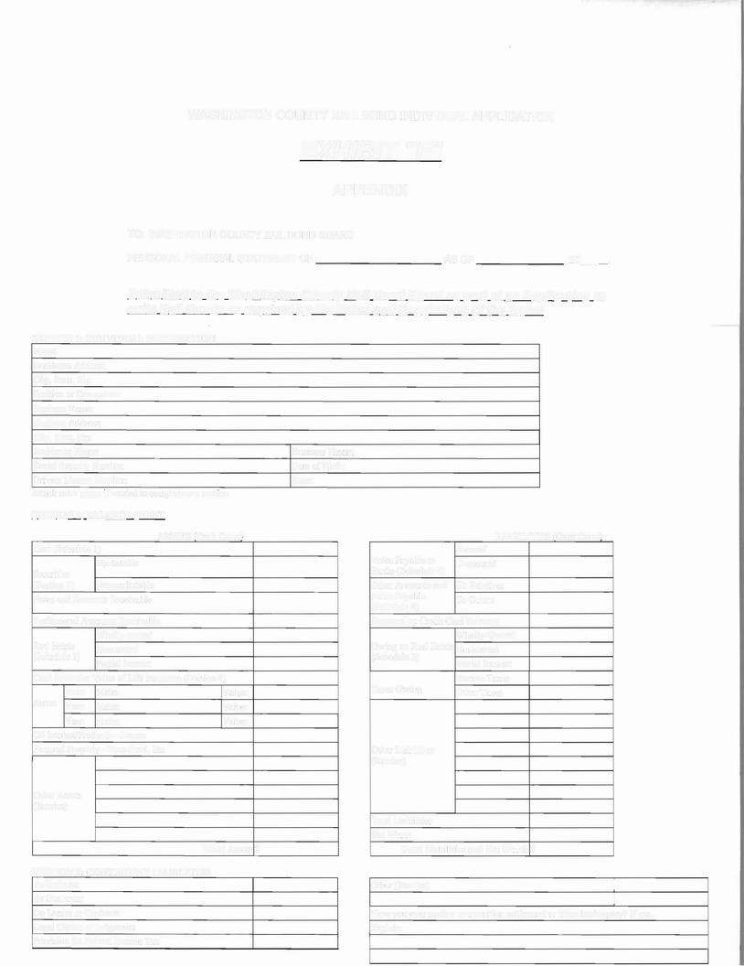

WALLER COUNTY BAIL BOND INDIVIDUAL APPLICATION

EXHIBIT "F"

APPENDIX

TO: WALLER COUNTY BAIL BOND BOARD

PERSONAL FINANCIAL STATEMENT OF AS OF , 20 .

***Submitted to the Waller County Bai] Bond Board as part of an Application to***

***write Bail Bonds as required by the Rules and Regulations of the Board***

|  |  |  |  |  |
| --- | --- | --- | --- | --- |
| **SECTION l · INDIVIDUAL INFORMATION**  Name: |  | | | |
| Residence Address: |
| City, State, Zip: |
| Position or Occupation: |
| Business Name: |
| Business Address: |
| City, State, Zip: |
| Residence Phone: | Business Phone: |  |  |  |
| Social Security Number: | Date of Birth: |  |  |  |
| Driver’s License Number: | State: |  |  |  |
| Attach extra pages if needed to complete any section |  |  |  |  |
| **SECTION 2; BALANCE SHEET** |  |  |  |  |
| ASSETS (Omit Cents) |  |  |  | LIABILITIES *(Omit* Cents) |
| Cash (Schedule I} |  |  | Secured |  |
| Marketable |  | Notes Payable to | Unsecured |  |
| Securities |  | Banks (Schedule 4) |  |  |

(Section 2) Nonmarketable

Notes and Accounts Receivable

Professional Accounts Receivable

Wholly-owned

Real Estate Homestead

(Schedule 3)

Partial Interest

Cash Surrender Value of Life Insurance (Section 4)

Year: **Make:** Value: Autos: **Year: Make:** Value:

**Year:** Make: Value: Oil Interest/Production Leases

Personal Property - Household, Etc.

Other Accounts and To Relatives

Notes Payable To Others

(Schedule 4}

Outstanding Credit Card Balances

Wholly-Owned

Owing on Real Estate Homestead

(Schedule 3)

Partial Interest

Income Taxes

Taxes Owing Other Taxes

Other Liabilities

(Itemize)

Other Assets

{Itemize}

**Total Assets/$**

Total Liabilities

Net Worth

**Total Liabilities and Net Worth[$**

**SECTION 3: CONTINGENT LIABILITIES**

As Endorser

As Guarantor

On Leases or Contracts Legal Claims or Judgments Provision for Federal Income Tax

Other (Itemize)

Have you ever made a composition settlement or taken bankruptcy? If yes,

Explain:

**SECTION 4: LIFE INSURANCE AND ANNUITIES (Including employer provided)**

NET CASH

PL.EDGED?

COMPANY FACE

AMOUNT

BENEFICIARY CASH VALUE POLICY LOAN

VALUE INSURED

YES or NO

**TOTAL!�$**

**SECTION 5: SCHEDULES**

**NUMBER** I: **CASH IN BANKS AND OTHER INSTITUTIONS**

NAME AND LOCATION TYPE OF ACCOUNT BALANCE ($)

**NUMBER 2a· SECURITIES-MARKETABLE** i..**e**.**. GOVERNMENT ISSUES LISTED SECURITIES**

**TOTALS**

Face Value of

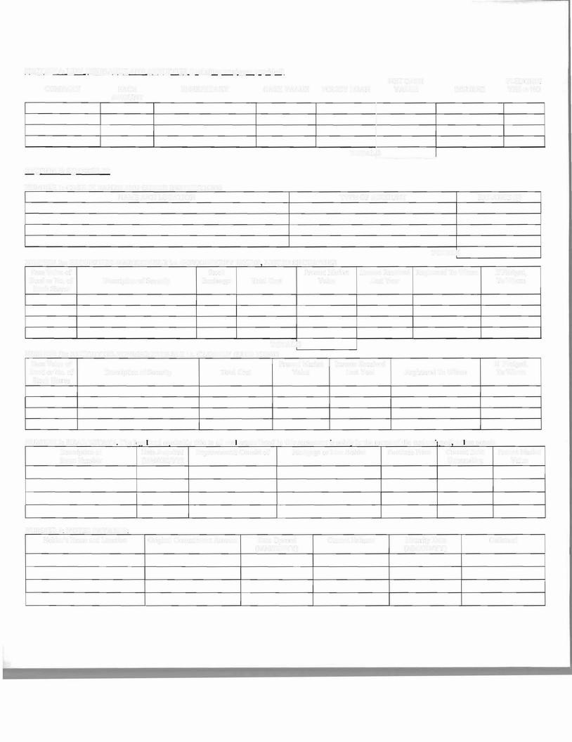

|  |  |  |  |  |
| --- | --- | --- | --- | --- |
|  | Stock | Present Market | Income Received Registered To Whom | If Pledged, |
| Bond or No. of Description  Stock Shares | of Security Exchange Total Cost | Value | Last **Year** | To Whom |

**TOTALIS NUMBER 2b: SECURITIES-NONMARKETABLE** i..**e .**. **CLOSELY HELD FIRMS**

Face Value of Present Market Income Received If Pledged, Bond or No. of Description of Security Total Cost Value Last Year Registered To Whom To Whom

Stock Shares

**NUMBER 3:**: **REAL ESTATE The** I**ega and eaui.ta bl e t.i tl**I**e to a**II **rea estate** li.**liste·d**ID **thiis statement is sol**I**el**I**v** i.n **the name** o:**f t'hi e un d/ersigned** unless note**d**:

|  |  |  |  |  |
| --- | --- | --- | --- | --- |
| Description or | Date Acquired | Improvements Consist of | Mortgage or Lien Holder | Purchase Price |
| Street Number | (MM/DD/YY) |  |  |  |

Current Debt Present Market

Outstanding Value

**NUMBER 4: NOTES PAYABLE:**

Holder's Name and Location Original Commitment Amount Date Opened Current Balance Maturity Date Collateral

(MM/DD/YY) (MM/DD/YY)



I, do hereby acknowledge that this personal financial statement is being prepared for the purpose of submitting to the Waller County Bail Bond Board an application for a license to write bail bonds in Waller County, Texas and that any false statement therein may be grounds for which the said Board may refuse to grant me a license to write bail bonds or upon which the Board may suspend or revoke my license to write bail bonds or refuse to renew my license.

I, upon oath and upon pains and penalties of perjury do hereby swear that the forgoing is a true, complete and accurate financial statement of myself, submitted by me to the Waller County Bail Bond Board on day of

, 20 .

License Applicant Signature

Date

SIGNED AND SWORN to before me on this day of , 20 .

NOTARY PUBLIC STATE OF TEXAS



WALLER COUNTY BAIL BOND INDIVIDUAL APPLICATION

***AUTHORIZATION OF RELEASE***

DATE:

I, _, (Surety)

DBA: , (Business Name)

License #

Address:

Telephone #:

Last 4 numbers of SSN:

give my permission to have the information that I have provided in my Financial Statement dated , to acquire or renew a license with the Waller County Bail Bond Board for the license period beginning (month and year), be released to the designated person assigned by the Board. This person can investigate any and all information provided in the attached copy of the financial statement I have filed with the Waller County Bail Bond Board.

This authorized person designated will have a letter of authority issued by the Waller County Bail Bond Board. This authorization is in effect until final action is taken by the Waller County Bail Bond Board on the application/renewal dated

, 20 .

Applicant Signature

Date

SIGNED AND SWORN to before me on this day of , 20 .

NOTARY PUBLIC STATE OF TEXAS



WALLER COUNTY BAIL BOND INDIVIDUAL APPLICATION

**EXHIBIT "G"**

LETTER OF REFERENCE

Date:

To the Waller County Bail Bond Board Members:

STATE OF TEXAS }{ COUNTY OF WALLER }{

Before me, the undersigned authority in and for the State of Texas, on this day personally appeared

who, after being duly sworn, deposes and said: My name is

, I am years of age and I live at

. I wish to state the following facts:

I, , have known (reference) (applicant)

for at least three (3) years. During this time, I have known (applicant)

as having a reputation of honesty, truthfulness, fair dealing, and competency.

I, , recommend that the application for a bail bond

(reference)

license be approved for . (applicant)

Reference's Printed Name

Reference's Printed Address

City State Zip Code

Reference's Telephone Number

Reference's Signature



Date

I have read the above statement consisting of page(s), which is based on my personal knowledge, and it true and correct.

Reference Signature

Date

SIGNED AND SWORN to before me this day of , 20 .

NOTARY PUBLIC STATE OF TEXAS



WALLER COUNTY BAIL BOND INDIVIDUAL APPLICATION

**EXHIBIT "H"**

**ASSIGNMENT OF SECURITY FOR BAIL BOND COLLATERAL**

To: Waller County Treasurer

From: , BAIL BOND LICENSE HOLDER

I, , (ASSIGNOR), hereby assign the SECURITY described below to the Treasurer of Waller County, Texas (ASSIGNEE).

SECURITY:

FINANCIAL INSTITUTION:

PAYABLE TO:

FACE AMOUNT:

DATED:

MATURITY DATE:

In order to obtain a Bail Bond License in Waller County, Texas and for the purpose of providing security for

Bail Bonds written in Waller County, Texas which may accrue or be authorized under the law,

the ASSIGNOR, for and on behalf of the Bail Bond License Holder in the name of the owner specified, assigns to the Waller County Treasurer any and all right, title, claim and interest of whatever nature of ASSIGNOR

in and to the SECURITY described above. The Waller County Treasurer has no interest or entitlement to any interest or dividends arising from this agreement. All the interest or dividends should continue to be payable to the ASSIGNOR, and in this regard, SECURITY for the purpose of the Assignment shall mean the FACE AMOUNT (Principal) not the interest accruing on account of the SECURITY.

ASSIGNOR agrees that this assignment carries with it the right to any insurance on the SECURITY that may exist now, or in the future, and includes the right of the Waller County Treasurer to negotiate,

redeem, collect or withdraw at any time any part of the FACE AMOUNT of the SECURITY to be applied as a payment to unpaid FINAL JUDGMENT(s) of any forfeitures of bail bonds written in Waller County, Texas. The right of the Waller County Treasurer to apply the SECURITY shall not be affected by a subsequent change in the trade name or business location of the person or entity on whose behalf the assignment is

executed. The ASSIGNOR further agrees that the Waller County Treasurer may, in its own discretion and at any time, transfer all or any part of the SECURITY into its own name to satisfy an unpaid FINAL JUDGMENT(s), or portion thereof, of any forfeiture of bail bonds written in Waller County, Texas. The Waller County Treasurer is hereby appointed attorney-in-fact for the ASSIGNOR with full power and

authority to execute any endorsements necessary to complete such a transfer and negotiation.

ASSIGNOR understands and agrees that by this Assignment, all right, title and claim to interest in, use of and control over the disposition of the SECURITY is relinquished and that such SECURITY may be released only by the Waller County Treasurer's written direction.

This document shall serve as notification by the ASSIGNOR to the FINANCIAL INSTITUTION of the term of this Assignment and Assignor's intention and agreement to be bound by said terms.

This Assignment is made subject to the following terms:

1. WARRANTY, ASSIGNOR expressly warrants that it has good title to the property conveyed by this Assignment, and that the property is free from prior encumbrances of any nature or kind. ASSIGNOR further warrants that the property will remain free from encumbrances of any kind or nature.



2. EXISTING LIABILITIES. This Assignment is subject to no existing obligations.

3. BINDING EFFECT. This Assignment and all of its terms and conditions are binding on ASSIGNOR and all his/her/its officers, agents, principals, vice principals, shareholders, stockholders, successors, heirs, devisees, spouses, and assigns.

License Applicant/Assignor Signature

Date

SIGNED AND SWORN to before me this day of , 20 .

NOTARY PUBLIC

STATE OF TEXAS



WALLER COUNTY BAIL BOND INDIVIDUAL APPLICATION

**FINANCIAL INSTITUTION ACKNOWLEDGEMENT**

STATE OF TEXAS }{ COUNTY OF WALLER }{

The FINANCIAL INSTITUTION acknowledges the assignment of the SECURITY described herein to the

Waller County Treasurer. FINANCIAL INSTITUTION acknowledges the Waller County Treasurer

has no interest or entitlement to any interest or dividends. FINANCIAL INSTITUTION certifies that it has recorded the assignment and has retained a copy. FINANCIAL INSTITUTION certifies that it does not have any knowledge of anyone else having any lien, encumbrance, right, hold, claim or obligation of the SECURITY. FINANCIAL INSTITUTION accepts the SECURITY with knowledge that it has been posted for and on behalf of the Bail Bond License Holder identified above and agrees to act as the sole agent for the purpose of holding

this SECURITY for the Waller County Treasurer's exclusive use. FINANCIAL INSTITUTION agrees not to release, make a payment, or otherwise divert or dispose of the SECURITY except in accordance with the

written instructions of the Waller County Treasurer. It is understood that notice to or consent of the ASSIGNOR to disposition of the SECURITY by the Waller County Treasurer shall not be required. FINANCIAL INSTITUTION further agrees not to exercise any set of rights it may have with respect to the SECURITY, or to otherwise impede, hinder, delay, prevent, obstruct or interfere with the Waller County Treasurer's right to negotiate, redeem, collect and withdraw this SECURITY promptly.

**ATTEST:**

FINANCIAL INSTITUTION ASSIGNOR

BY:

BY:

Printed Name:

Printed Name:

Job Title:

Job Title:

Date:

Date:



DEED OF TRUST

*******************************

**TERMS**

Date:

, 20

Grantor:

Grantor's Mailing Address:

Trustee: Chair of the Waller County Bail Bond Board

Trustees Mailing Address: 645 12th Street, Hempstead, Texas 77445

Bondholder: Waller County Bail Bond Board

Bondholder's Mailing Address: 645 12th Street, Hempstead, Texas 77445

Bond(s): All present and future Bail Bonds issued by Grantor in

Waller County, Texas to Bondholder.

Grantor is pledging $ of the appraised value

$ of the pledged property.

Property (including any improvements):

Per Lien:

Other Exceptions to Conveyance and Warranty:

This conveyance is subject to all valid building and use restrictions, easements, and right-of-way of record, visible or apparent, if any, and valid reservations of oil, gas and other interests, if any.

For value received and to secure payment of the Bond(s), Grantor conveys the Property to Trustee in trust. Grantor warrants and agrees to defend the title to the Property, subject to the other Exceptions to Conveyance and Warranty. When Grantor ceases issuing bonds in Waller County, Texas and upon payment of the Bond(s) and all other amounts secured by this deed of trust, this deed of trust will have no further effect, and Bondholder will release it at Grantor's expense.

**CLAUSES AND COVENANTS**

A. Grantor's Obligations (Applicant) Grantor agrees to:

1. Keep the property in good repair and condition;

2. Pay all taxes and assessments on the property before delinquency;

3. Defend title to the property subject to other Exceptions to Conveyance and Warrant and preserve the lien's priority as it established in this deed of trust;

4. Maintain, in a form acceptable to Bondholder, an insurance policy that:

a. Covers all improvements for their full insurable value as determined when the policy is issued and renewed, unless Bondholder approves a smaller amount in writing:

b. Contains an 80.0% co-insurance clause;

c. Provides fire and extended coverage, including windstorm clause;

d. Protects Bondholder with a standard mortgage clause;

e. Provides flood insurance at any time the Property is in a flood hazard are; and f. Contains such other coverage as Bondholder may reasonably require.

5. Comply at all times with the requirements of the 80.0% co-insurance clause;

6. Deliver the insurance policy to Bondholder within ten (10) days of the date of this deed of trust and deliver renewals to Bondholder at least fifteen (15) days before expiration;

7. Obey all laws, ordinances, and restrictive covenants applicable to the Property;



8. Keep any buildings occupied as required by the insurance policy; and,

9. If the lien of this deed of trust is not a first lien, pay or cause to be paid all prior lien notes and abide by or cause to be abided by all prior lien instruments.

B. Bondholder's Rights (Bail Bond Board)

1. Bondholder may appoint in writing a substitute trustee, succeeding to all rights and responsibilities of

Trustee.

2. Bondholder may, from any proceeds received under the insurance policy, either (1) retain the proceeds as a cash bond or (2) repair or replace damaged or destroyed improvements covered by the policy.

3. If the Grantor fails to perform any of the Grantor's obligations, Bondholder may perform those obligations and be reimbursed by Grantor on demand for any amounts so paid, including attorney's fees, plus interest on those amounts from the dates of payments at the lesser of 18.0% per annum or the maximum rate allowed by law. The amount to be reimbursed will be secured by this deed of trust.

4. If a final judgment forfeiting a Bond is entered against the Grantor and Grantor fails to immediately pay the amount of the final judgment, or if Grantor fails to perform any of Grantor's obligations and the default continues after any required notice of the default and the time allowed to cure, Bondholder may -

a. Direct Trustee to foreclose this lien, in which case Bondholder or Bondholder's agent will cause notice of the foreclosure sale to be given as provided by the Texas property Code as then in effect; and,

b. Purchase the property at any foreclosure sale by offering the highest bid and then have the bid credited on the amount of the final judgment(s).

5. Bondholder may remedy any default without waiving it and may waive any default without waiving any prior or subsequent default.

C. Trustee's Rights and Duties (Board Chair or designee)

If directed by Bondholder to foreclose the lien, Trustee will-

1. Either personally or by agent give notice of the foreclosure sale as required by the Texas Property

Code as then in effect;

2. Sell and convey all or part of the property "as is" to the highest bidder for cash with a general warranty binding Grantor, subject to the prior lien and to other Exceptions to Conveyance and Warranty and without representation or warranty, express or implied by Trustee;

3. From the proceeds of the sale, pay, in this order -

a. Expenses of foreclosure, including a reasonable commission to Trustee;

b. To Bondholder, the full amount of principal, interest, attorney's fees, and other charges due and unpaid;

c. Any amounts required by law to be paid before payment to Grantor; and, d. To Grantor, any balance; and,

4. Be indemnified by Bondholder against all costs, expenses, and liabilities incurred by Trustee for acting in the execution or enforcement of the trust created by this deed of trust, which includes all court and other costs, including attorney's fees, incurred by Trustee in defense of any action or proceeding taken against Trustee in that capacity.

D. General Provisions

1. If any of the property is sold under this deed of trust, Grantor must immediately surrender Possession to the purchaser. If Grantor fails to do so, Grantor will become a tenant at sufferance of the purchaser, subject to an action of forcible detainer.

2. Recitals in any Trustee's deed conveying the property will be presumed to be true.

3. Proceeding under this deed of trust, filing suit for foreclosure, or pursuing any other remedy will not constitute an election of remedies.

4. This lien will remain superior to liens later created even if (i) the maturity date for the Bond(s) is dated after the date hereof or (ii) part of the property is released.

5. Grantor assigns the Bondholder all amount payable to or received by Grantor from condemnation of all or part of the property, from private sale in lieu of condemnation, and from damages caused by public works or construction on or near the property. After deducting any expenses incurred, including attorney's fees and court and other costs, Bondholder will either release any remaining amounts to Grantor or hold such amount as a cash bond. Bondholder will not be liable for failure to collect or to exercise diligence in collecting any such amounts. Grantor will immediately give Bondholder notice of any actual or threatened proceedings for condemnation of all or part of the property.



6. Grantor assigns to Bondholder absolutely, not only as collateral, all present and future rent an other income and receipts from the property. Grantor warrants the validity and enforceability of the assignment. Grantor may as Bondholder's licensee collect rent and other income and receipts as long as the Grantor is not in default under any Bond(s) or this deed of trust. If Grantor defaults in payment of any Bond(s) or performance of this deed of trust, Bondholder may terminate Grantor's license to collect rent and other income and then as Grantor's agent may rent the property and collect all rent and other income and receipts. Bondholder neither has nor assumes any obligations

as lessor or landlord with respect to any occupant of the property. Bondholder may apply all rent and other income and receipts collected under this paragraph first to expenses incurred in exercising Bondholder's rights and remedies and then to Grantor's obligations under the Bond(s) and this deed of trust under in order determined by Bondholder. Bondholder is not required to act under this paragraph, and acting under this paragraph does not waive any of Bondholder's other rights and remedies. If Grantor becomes a voluntary or involuntary debtor in bankruptcy, Bondholder's filing a proof of claim in bankruptcy will be determined equivalent to the appointment of a receiver under Texas law.

7. Interest on the debt secured by this deed of trust will not exceed the maximum amount of non- usurious interest that may be contracted for, take, reserved, charged, or received under law. Any interest is excess of that maximum amount will be credited on the principal of the debt or, if that has been paid, refunded. On any acceleration or required or permitted prepayment, any such excess will be canceled automatically as of the acceleration or prepayment of, if already paid, credited on the principal of the debt or, if the principal of the debt has been paid, refunded. This provision overrides any conflicting provisions in this and all other instruments concerning the debt.

8. At least 15 days before taxes and assessments on the property become delinquent, Grantor agrees to furnish Bondholder evidence satisfactory to Bondholder that all taxes and assessments on the property have been paid.

9. When the context requires, singular nouns, pronouns include plural.

10. The term Bond(s) includes all present and future Bond(s) issued by Grantor to Bondholder and all amounts secured by this deed of trust.

11. This deed of trust binds, benefits, and may be enforced by successors in interest of all parties.

12. Grantor and each surety, endorser, and guarantor of the Bond(s) waive all demand for payment, presentation for payment, notice of intention to accelerate maturity, notice of acceleration of maturity, protest, and notice of protest, to the extent permitted by law.

13. Grantor agrees to pay reasonable attorney's fees, trustee's fees, and court and other costs of enforcing Bondholder's rights under this deed of trust if this deed of trust is placed in the hands of an attorney for enforcement.

14. If any provision of this deed of trust is determined to be invalid or unenforceable, the validity or enforceability of any other provision will not be affected.

15. Grantor represents that this deed of trust is given to secure all Bond(s) presently issued to

Bondholder and which may be issued to Bondholder in the future.

License Applicant/Grantor Signature

Date

SIGNED AND SWORN to before me this day of , 20 .

NOTARY PUBLIC STATE OF TEXAS



WALLER COUNTY BAIL BOND APPLICATION

**EXHIBIT "I"**

**Real Estate Documentation**

**This Exhibit shall include the following documents:**

a. Legal description of property.

b. Current statements for each taxing entity. c. The property's net value.

d. A statement of whether the applicant is married; and if the applicant is married, a sworn statement for the applicant's spouse agreeing to transfer to the Board.

e. A statement of the existence of a co-owner of the property and, if so,

a sworn statement from the co-owner agreeing to transfer to the Board. f. A photograph of the property is attached.

g. A proposed Deed of Trust in the form approved by the Board which is attached hereto.

* Statement agreeing to keep all taxes paid.

* Statement agreeing to not further encumber the property.

* Statement agreeing to maintain insurance on any improvements.

* Statement agreeing to name the Washington County Bail Bond Board as beneficiary of the insurance on the improvement

h. A Non-Homestead Affidavit and Designation of Homestead as approved by the Board, which is attached hereto.



WALLER COUNTY BAIL BOND INDIVIDUAL APPLICATION

N**ON-HOMESTEAD AFFIDAVIT AND DESIGNATION OF HOMESTEAD (SINGLE APPLICANT)**

STATE OF TEXAS }{ COUNTY OF WALLER }{

BEFORE ME, the undersigned authority, on this day personally appeared

, who, after being duly sworn, upon oath deposes and says:

Affiant does not now reside upon, use in any manner, nor claim as a business or residence homestead, nor has any present intention of ever in the future residing upon, using or claiming as either a business or residence homestead, the following described property. Affiant hereby renounces and disclaims any homestead right, interest or exemption in such property, to wit: (describe pledged property)

Affiant now resides upon, use and claim as his/her legal homestead the following described property: (describe homestead property)

which said last described property is improved with a dwelling house, is amply sufficient as a residence homestead for Affiant, and the fee simple title is vested in Affiant. Affiant hereby sets apart and designates the said last described property as the homestead to which he/she is entitled, under the Constitution and Laws of the State of Texas, exempt from forced sale, and Affiant further declares that said property last described is all of the property and the only property to which he/ she is now entitled as a homestead exempt from forced sale.

That this affidavit and designation is made to induce the Waller County Bail Bond Board to grant or renew a license, or to increase the collateral related to such license, to operate as a bail bond surety for the execution of bail bonds secured by a deed of trust upon the property first describe above.

EXECUTED this day of , 20 .

License Applicant Signature

Date

SIGNED AND SWORN to before me on this day of , 20 .

NOTARY PUBLIC STATE OF TEXAS



WALLER COUNTY BAIL BOND INDIVIDUAL APPLICATION

N**ON-HOMESTEAD AFFIDAVIT AND DESIGNATION OF HOMESTEAD (MARRIED APPLICANT)**

STATE OF TEXAS }{ COUNTY OF WALLER }{

BEFORE ME, the undersigned authority, on this day personally appeared

and spouse , who, after being duly sworn, upon oath deposes and says:

Neither of them now resides upon, use in any manner, nor claims as a business or residence homestead, nor has any present intention of ever in the future residing upon, using or claiming as either a business or residence homestead, the following described property: Each hereby renounces and disclaims any homestead right, interest or exemption in such property, to wit: (describe pledged property)

That they now reside upon, use and claim as their legal homestead the following described property: (describe homestead property)

which said last described property is improved with a dwelling house, is amply sufficient as a residence homestead for Affiant, and the fee simple title is vested in them. They hereby set apart and designate the said last described property as the homestead to which their family is entitled, under the Constitution and Laws of the State of Texas, exempt from forced sale, and they further declare that said property last described is all of the property and the only property to which they are now entitled as a homestead exempt from forced sale.

That this affidavit and designation is made to induce the Waller County Bail Bond Board to grant or renew a license, or to increase the collateral related to such license, to operate as a bail bond surety for the execution of bail bonds secured by a deed of trust upon the property first describe above.

EXECUTED this day of , 20 .

License Applicant Signature

Date



SIGNED AND SWORN to before me on this day of , 20 .

NOTARY PUBLIC STATE OF TEXAS

EXECUTED this day of , 20 .

Spouse Signature

Date

SIGNED AND SWORN to before me on this the day of , 20 .

NOTARY PUBLIC STATE OF TEXAS



WALLER COUNTY BAIL BOND INDIVIDUAL APPLICATION



N**ON-HOMESTEAD AFFIDAVIT AND DESIGNATION OF HOMESTEAD (CO-OWNER)**

STATE OF TEXAS }{ COUNTY OF WALLER }{

BEFORE ME, the undersigned authority, on this day personally appeared

and spouse , who, after being duly sworn, upon oath deposes and says:

Neither of them now reside upon, use in any manner, nor claims as a business or residence homestead, nor has any present intention of ever in the future residing upon, using or claiming as either a business or residence homestead, the following described property. Each hereby renounces and disclaims any homestead right, interest or exemption in such property, to wit: (describe pledged property)

That they now reside upon, use and claim as their legal homestead the following described property: (describe homestead property)

which said last described property is improved with a dwelling house, is amply sufficient as a residence homestead for Affiant, and the fee simple title is vested in them. They hereby set apart and designate the said last described property as the homestead to which their family is entitled, under the Constitution and Laws of the State of Texas, exempt from forced sale, and they further declare that said property last described is all of the property and the only property to which they are now entitled as a homestead exempt from forced sale.

That this affidavit and designation is made to induce the Waller County Bail Bond Board to grant or renew a license, or to increase the collateral related to such license, to operate as a bail bond surety for the execution of bail bonds secured by a deed of trust upon the property first describe above.

EXECUTED this day of , 20 .

License Applicant Signature

Date

SIGNED AND SWORN to before me on this day of , 20 .

NOTARY PUBLIC STATE OF TEXAS



EXECUTED this day of , 20 .

Co-Owner Signature

Date

SIGNED AND SWORN to before me on this the day of , 20 .

NOTARY PUBLIC STATE OF TEXAS

EXECUTED this day of , 20 .

Co-Owner Signature

Date

SIGNED AND SWORN to before me on this the day of , 20 .

NOTARY PUBLIC STATE OF TEXAS

EXECUTED this day of , 20 .

Co-Owner Signature

Date

SIGNED AND SWORN to before me on this the day of , 20 .

NOTARY PUBLIC STATE OF TEXAS



WALLER COUNTY BAIL BOND INDIVIDUAL APPLICATION



**EXHIBIT "J"**

**APPLICANT'S STATEMENTS REGARDING LICENSURE IN ANOTHER COUNTY**

STATE OF TEXAS }{ COUNTY OF WALLER }{

Before me, the undersigned authority in and for the State of Texas, on this day personally appeared

, who, after being duly sworn, deposes and said: My name is

, I am years of age and I live at

. I wish to state the following facts:

As of the date of this application, I am or have been licensed in another county. The following is a list of each county in which I hold or have held a license.

**COUNTY DATE OF LICENSE**

I have read the above statement consisting of page(s), which is based on my personal knowledge, and it is true and correct.

License Applicant Signature

Date

SIGNED AND SWORN to before me on this day of , 20 .

NOTARY PUBLIC STATE OF TEXAS



WALLER COUNTY BAIL BOND INDIVIDUAL APPLICATION

**EXHIBIT "K"**

**FINAL JUDGMENTS REGARDING BAIL BONDS**

STATE OF TEXAS }{ COUNTY OF WALLER }{

Before me, the undersigned authority in and for the State of Texas, on this day personally appeared

, who being by me duly sworn on oath the above stated:

(Applicant must check #1 or #2)

1. As of the date of this application I have NO final judgments executed by me as a surety or as an agent for a surety in any county that have been unpaid for more than thirty (30) days and that arose directly or indirectly for any bail bond;

OR

2. As of the date of this application the following final judgment(s) that arose directly or indirectly from a bail bond executed by me as a surety or as an agent for a surety remain unpaid for more than thirty (30) days after issuance.

COUNTY COURT DEFENDANT'S NAME JUDGMENT DATE LIABILITY

TOTAL NUMBER OF FINAL JUDGMENTS

TOTAL AMOUNT OF LIABILITY

License Applicant Signature

Date

SIGNED AND SWORN to before me on this day of , 20 .

NOTARY PUBLIC STATE OF TEXAS



WALLER COUNTY BAIL BOND INDIVIDUAL APPLICATION

**EXHIBIT "L"**

**APPLICANT'S STATEMENT REGARDING CIVIL LITIGATION**

STATE OF TEXAS }{ COUNTY OF WALLER }{

Before me, the undersigned authority in and for the State of Texas, on this day personally appeared

, who after being by me duly sworn, deposes and said: My name is: , I am years of age and I live at

. I wish to state the following facts:

**As of the date of this application, I am presently involved in civil litigation as listed below:**

COUNTY COURT CASE# PLAINTIFF'S NAME DEFENDANT'S NAME

|  |
| --- |
|  |
|  |
|  |
|  |
|  |

I have read the above statement consisting of page(s), which is based on my personal knowledge, and it is true and correct.

License Applicant Signature

Date

SIGNED AND SWORN to before me on this day of , 20 .

NOTARY PUBLIC STATE OF TEXAS



WALLER COUNTY BAIL BOND INDIVIDUAL APPLICATION



**EXHIBIT "M"**

STATE OF TEXAS }{ COUNTY OF WALLER }{

Before me, the undersigned authority in and for the State of Texas, on this day personally appeared , who, after being duly sworn, deposes and said: My name is , I am years of age and I live at

. I wish to state the following facts:

**Attached hereto is a copy of all outstanding, unsatisfied Judgments pending against me.**

I have read the above statement consisting of page(s), which is based on my personal knowledge, and it is true and correct.

License Applicant Signature

Date

SIGNED AND SWORN to before me this day of , 20 .

NOTARY PUBLIC STATE OF TEXAS



WALLER COUNTY BAIL BOND INDIVIDUAL APPLICATION



**EXHIBIT "N"**

STATE OF TEXAS }{

COUNTY OF WALLER }{

BEFORE ME, the undersigned authority on this day personally appeared

who being duly sworn on oath the above stated:

As of the date of this Application, I have been denied a bail bond surety or had a license suspended or revoked as stated below:

COUNTY DATE ACTION REASON

(DENIAL, SUSPENSION OR REVOCATION)

License Applicant Signature

Date

SIGNED AND SWORN to before me on this day of , 20 .

NOTARY PUBLIC STATE OF TEXAS



WALLER COUNTY



BAIL BOND EMPLOYEE APPLICATION FORM

**PLEASE PRINT CLEARLY OR TYPE ALL INFORMATION**

1.

Last Name First Name Middle Name

Any other name ever used:

2.

Home Street Address City State Zip Code

3.

Home Telephone Work Telephone Cellular Telephone

4.

Date of Birth (MM-DD-YYYY)

5.

6.

Driver License Number State Social Security Number

7.

8.

Name of Bonding Company Bonding Company Telephone Number

9. Have you been convicted of an offense other than traffic violations: { } YES { } NO If YES, provide the following information for each conviction or probation:

CHARGE DATE COUNTY DISPOSITION

|  |
| --- |
|  |
|  |
| **Continue on separate sheet, if necessary**  10. Do you currently have criminal charges pending against you? { } YES { } NO If YES, provide the following information for each pending charge:  CHARGE DATE COUNTY STATUS |
|  |
|  |

**CONTINUE OF SEPARATE PAGE, IF NECESSARY.**



I hereby swear and affirm that the foregoing information is true and correct and that there are no omissions. I understand that a criminal history check will be conducted and that any evasion, false statement, answer or omission shall be grounds for denial of this application which could result in criminal charges against me. I affirm that I have received, read and understand the policies, rules and regulations of the Waller County Bail Bond Board and agree to abide by the same.



Employee Applicant Signature

Date

SIGNED AND SWORN to before me on this day of , 20 .

NOTARY PUBLIC STATE OF TEXAS

===========================================================================

I request that the above named employee applicant be granted, NOT be granted and

Employee Identification Card.

Name of Bonding Company Agent/Licensee

Date License Number

